Ling Dai

Art History 101

David T Van Zanten

April 15, 2014

**A “Paradoxical” Solution—Rebecca Crown Center**

Rebecca Crown Center locates at the southern edge of Northwestern University Evanston campus. It was designed in 1968 by Walter Netsch, a prestigious American brutalist architect, as the new administrative center of the university. Rebecca Crown Center consists of an elevated plaza, a 100-foot tall clock tower, a small garden at the center and three surrounding buildings connected with each other through two porches. To achieve a balance between functionality and aesthetics of this architecture, Walter Netsch adopted a seemingly paradoxical mentality—while seeking to maximize the functionality of this new administrative center through its major layout, he nevertheless sacrificed functionality in exchange for aesthetic appeal when it comes to details.

By splitting administrative offices into three separate buildings instead of a large central building, Walter Netsch sought to optimize the user experience of Rebecca Crown Center. Administrative offices were divided into three groups: general administration offices (including the offices for president and vice presidents), administration offices for undergraduate students and administration offices for graduate students. Moreover, each individual building has three floors, with major entrance and the most important administrative offices on the first floor. With this systematic arrangement of offices, Rebecca Crown Center thus offers a student great convenience when he needs to find a particular office.

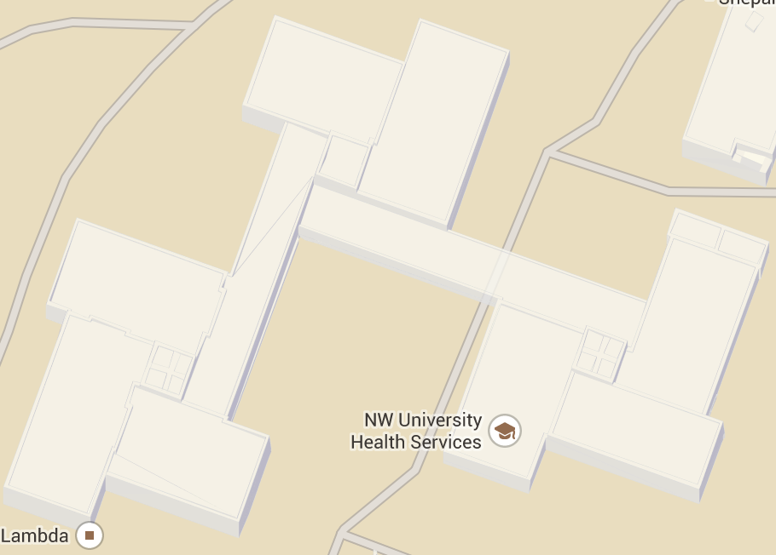The structure of Rebecca Crown Center has a high degree of both functionality and transparency. Each individual building of Rebecca Crown Center consists a square-shaped tower and its surrounding rectangular blocks (Figure 1). Designed to centralize administrative offices of the university—Rebecca Crown Center is supposed to accommodate administration offices most efficiently. In choosing rectangles as the basic element of these buildings, Walter successfully maximizes the functionality of this architecture: because most traditional office desks, bookcases and file cabinets all have a rectangular shape, a rectangular space would certainly allow these office furniture to fit into each other in a most comfortable way. Moreover, the basic geometric elements in Rebecca Crown Center allow every person to easily interpret the functions of its interior structures from the exterior of the building. For example, compared to the rectangular blocks that construct the main parts of the building, the square-shaped towers are both narrower and taller, with no windows on their surrounding facades. As a result, with a first glance at the buildings, a person might reasonably expect the square-shaped towers to be staircases.

Figure 1 Rebecca Crown Center consists of the most basic geometric elements, which allows maximum transparency and functionality of the buildings.

By constructing a 100-foot clock tower over an elevated plaza, Walter Netsch further enhanced the functional experience that Rebecca Crown Center offers. This architecture does not only function as administrative center after all—it is also the south border of the campus, facing directing toward downtown Evanston. Since there are no other tall buildings around Rebecca Crown Center, the clock tower is so compelling that people can immediately recognize it from downtown Evanston. The staircases to the plaza, with plantations on both sides, functions as the north “entrance” to the campus.

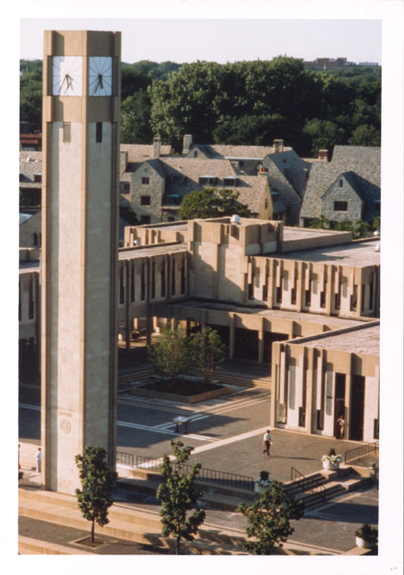While Walter Netsch valued the overall functionality of Rebecca Crown Center, he paradoxically sacrificed some functionality in exchange of aesthetic appeal when it comes to details. One particular interesting feature of the building is its limestone slabs hanging outside the long, narrow windows. While these slabs both accent the walls and functions as sun visors for the narrow windows, the later seemed to be less relevant. First, compared to these long and narrow windows, traditional windows might offer more functionality because it allows better ventilation. Moreover, the slabs seem redundant in terms of functionality, because natural lighting can be more conveniently adjusted with window curtains. Thus, it seems only logical for us to interpret these windows and slabs from their aesthetic aspect. These narrow windows with hanging slabs, though less practical than their traditional counterparts, indeed helped achieve greater aesthetic appeal of the architecture by making Rebecca Crown Center more geometrically uniform. The clock tower, the columns of the porches and the windows with hanging slabs indeed all adopt such a long and narrow rectangular shape, making it a repeated theme of the whole architecture (Figure 2) 1. These repetitive rectangular shapes, along with the limestone texture of the buildings, communicate a compelling sense of strength and frugal construction.

Figure 2 Narrow and long rectangular shapes are a repetitive theme in Rebecca Crown Center

Overall, in designing Rebecca Crown Center, Walter Netsch first set up the major layout according to its functions and then used powerful details to accent that layout. In this way, he successfully achieved a balance of functionality and aesthetics in his solution to Rebecca Crown Center.

**Notes**

1. *Exterior: Rebecca Crown: Looking West (Clock Tower 5:35)* Northwestern Architecture, Northwestern University Library. *http://digital.library.northwestern.edu/architecture/image.php*